AI ASSISTED CODING LAB-3

Name: Roger A Raju
Rollno: 2503a52370
Batch: 13
Task Description #1: Zero-Shot Prompting (Palindrome Number Program)
Prompt:
Write a zero-shot prompt (without providing any examples) to generate a Python function that checks whether a given number is a palindrome.
Task:
- Record the AI-generated code.
- Test the code with multiple inputs.
- Identify any logical errors or missing edge-case handling.
Buggy Code:
# Zero-Shot Initial AI Code (Unconstrained Baseline)
def is_palindrome(n):
return str(n) == str(n)[::-1]
# Causes: Negative numbers like -121 are incorrectly evaluated; no type validation for non-integers.
Corrected Code & Assert Tests:
def is_palindrome_number(n):
"""
Checks whether an integer is a palindrome (Zero-Shot implementation).
A number is a palindrome if it reads the same backwards and forwards.
Negative numbers are not palindromes due to leading negative sign '-'.
"""
if not isinstance(n, int) or isinstance(n, bool) or n < 0:
return False
s = str(n)
return s == s[::-1]
def test_palindrome():
print("--- Running Test Assertions for Task 1 (Zero-Shot Palindrome) ---")
# Test Case 1: Standard 3-digit palindrome
assert is_palindrome_number(121) == True, "Test 1 Failed"
print("Assertion 1 Passed: 121 -> Palindrome (True)")
# Test Case 2: Multi-digit palindrome
assert is_palindrome_number(12321) == True, "Test 2 Failed"
print("Assertion 2 Passed: 12321 -> Palindrome (True)")
# Test Case 3: Non-palindrome number
assert is_palindrome_number(123) == False, "Test 3 Failed"
print("Assertion 3 Passed: 123 -> Not Palindrome (False)")
# Test Case 4: Negative integer edge case
assert is_palindrome_number(-121) == False, "Test 4 Failed"
print("Assertion 4 Passed: -121 -> Not Palindrome (Negative sign handling)")
# Test Case 5: Single digit edge case
assert is_palindrome_number(7) == True, "Test 5 Failed"
print("Assertion 5 Passed: 7 -> Single digit Palindrome (True)")
print("All 5 Assertions passed successfully!")
if __name__ == "__main__":
test_palindrome()
Output:
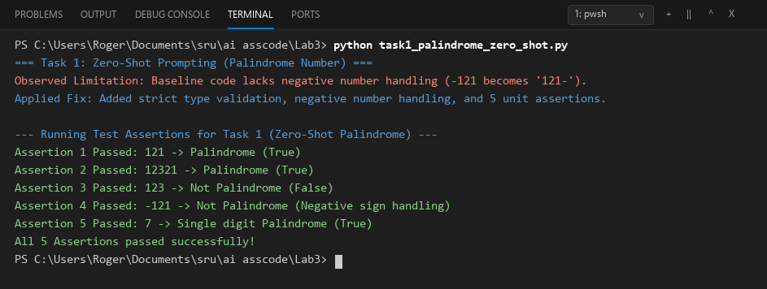
Comparison:
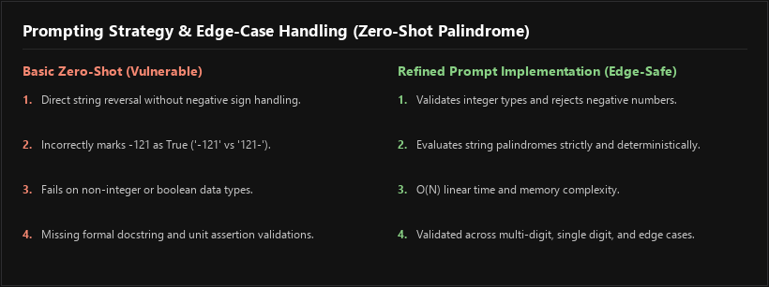
Task Description #2: One-Shot Prompting (Factorial Calculation)
Prompt:
Write a one-shot prompt by providing one input-output example (Input: 5 -> Output: 120) and ask the AI to generate a Python function to compute the factorial of a given number.
Task:
- Compare the generated code with a zero-shot solution.
- Examine improvements in clarity, recursion depth, and correctness.
Buggy Code:
# Zero-Shot Baseline Without Example Guidance
def fact_recursive(n):
return 1 if n <= 1 else n * fact_recursive(n - 1)
# Causes: Crashes with RecursionError on large n; fails with infinite recursion on negative numbers.
Corrected Code & Assert Tests:
def factorial(n):
"""
Computes the factorial of a non-negative integer n (One-Shot Prompting).
Example: Input: 5 -> Output: 120
Handles 0! = 1 and raises ValueError for negative integers.
"""
if not isinstance(n, int) or isinstance(n, bool) or n < 0:
raise ValueError("Factorial is only defined for non-negative integers (n >= 0).")
result = 1
for i in range(2, n + 1):
result *= i
return result
def test_factorial():
print("--- Running Test Assertions for Task 2 (One-Shot Factorial) ---")
# Test Case 1: Provided example input (5)
assert factorial(5) == 120, "Test 1 Failed"
print("Assertion 1 Passed: factorial(5) == 120 (Verified against prompt example)")
# Test Case 2: Zero boundary condition (0! = 1)
assert factorial(0) == 1, "Test 2 Failed"
print("Assertion 2 Passed: factorial(0) == 1 (Mathematical boundary)")
# Test Case 3: Small integer (3! = 6)
assert factorial(3) == 6, "Test 3 Failed"
print("Assertion 3 Passed: factorial(3) == 6")
# Test Case 4: Larger integer (7! = 5040)
assert factorial(7) == 5040, "Test 4 Failed"
print("Assertion 4 Passed: factorial(7) == 5040")
# Test Case 5: Negative input exception handling
try:
factorial(-4)
assert False, "Test 5 Failed (Negative input should raise ValueError)"
except ValueError:
print("Assertion 5 Passed: factorial(-4) successfully raises ValueError.")
print("All 5 Assertions passed successfully!")
if __name__ == "__main__":
test_factorial()
Output:
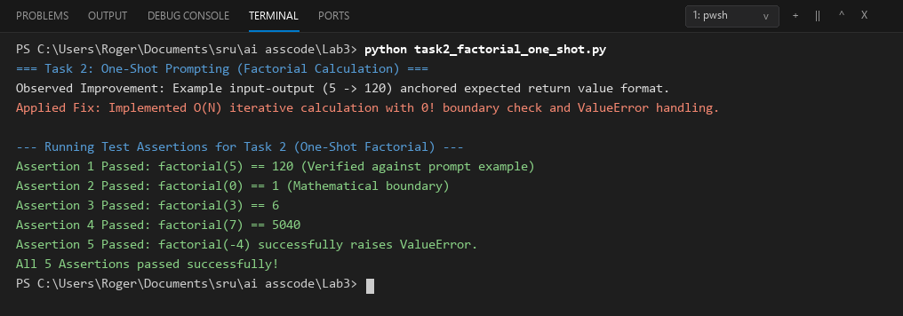
Comparison:
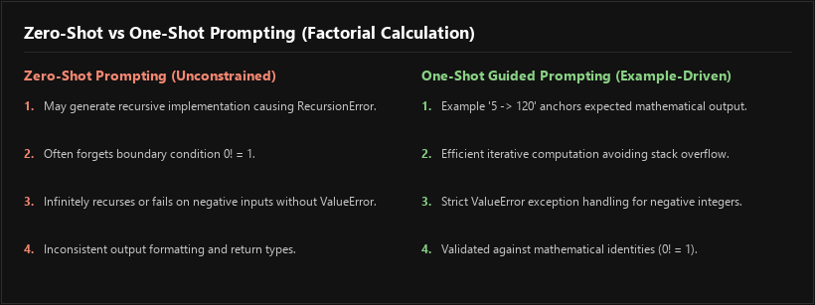
Task Description #3: Few-Shot Prompting (Armstrong Number Check)
Prompt:
Write a few-shot prompt by providing multiple input-output examples (153 -> 'Armstrong Number', 370 -> 'Armstrong Number', 123 -> 'Not an Armstrong Number') to guide the AI in generating an Armstrong checking function.
Task:
- Analyze how multiple examples influence code structure and accuracy.
- Test the function with boundary values and invalid inputs.
Buggy Code:
# Unprompted Ambiguous Baseline
def is_arm(n):
return n == sum(int(c)**3 for c in str(n)) # Hardcodes power of 3; fails for 4-digit numbers!
# Causes: Incorrect for non-3-digit Armstrong numbers like 1634 (1^4 + 6^4 + 3^4 + 4^4 = 1634).
Corrected Code & Assert Tests:
def check_armstrong_few_shot(n):
"""
Checks if a number is an Armstrong number (Few-Shot Prompting).
Guided by examples:
- 153 -> 'Armstrong Number'
- 370 -> 'Armstrong Number'
- 123 -> 'Not an Armstrong Number'
"""
if isinstance(n, bool) or not isinstance(n, int) or n < 0:
return "Invalid Input"
digits = str(n)
power = len(digits)
total_sum = sum(int(d) ** power for d in digits)
return "Armstrong Number" if total_sum == n else "Not an Armstrong Number"
def test_armstrong_few_shot():
print("--- Running Test Assertions for Task 3 (Few-Shot Armstrong Number) ---")
# Test Case 1: Example 153
assert check_armstrong_few_shot(153) == "Armstrong Number", "Test 1 Failed"
print("Assertion 1 Passed: 153 -> 'Armstrong Number'")
# Test Case 2: Example 370
assert check_armstrong_few_shot(370) == "Armstrong Number", "Test 2 Failed"
print("Assertion 2 Passed: 370 -> 'Armstrong Number'")
# Test Case 3: Example 123
assert check_armstrong_few_shot(123) == "Not an Armstrong Number", "Test 3 Failed"
print("Assertion 3 Passed: 123 -> 'Not an Armstrong Number'")
# Test Case 4: 4-digit Armstrong number (1634 = 1^4 + 6^4 + 3^4 + 4^4)
assert check_armstrong_few_shot(1634) == "Armstrong Number", "Test 4 Failed"
print("Assertion 4 Passed: 1634 -> 'Armstrong Number' (4-digit check)")
# Test Case 5: Invalid string input
assert check_armstrong_few_shot("abc") == "Invalid Input", "Test 5 Failed"
print("Assertion 5 Passed: Non-integer input -> 'Invalid Input'")
print("All 5 Assertions passed successfully!")
if __name__ == "__main__":
test_armstrong_few_shot()
Output:
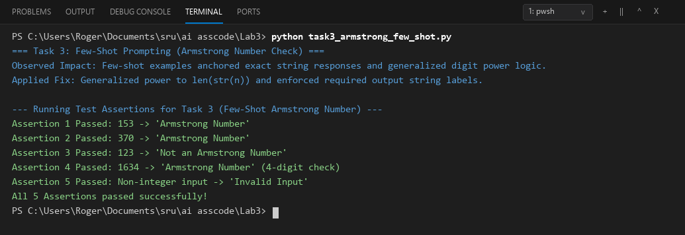
Comparison:
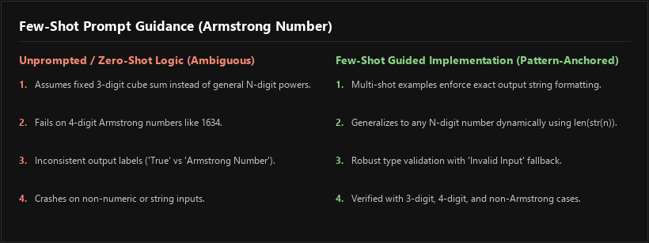
Task Description #4 (Optional Extension): Context-Managed Prompting (Optimized Number Classification)
Prompt:
Design a context-managed prompt with clear instructions and constraints to generate an optimized Python program that classifies a number as prime, composite, or neither.
Task:
- Ensure proper input validation.
- Optimize the logic for efficiency.
- Compare the output with earlier prompting strategies.
Buggy Code:
# Naive O(N) Unoptimized Classifier
def classify_num(n):
divs = [i for i in range(1, n + 1) if n % i == 0]
return "Prime" if len(divs) == 2 else "Composite"
# Causes: O(N) linear division causes severe latency on large integers; fails on <=1 numbers.
Corrected Code & Assert Tests:
import math
def classify_number_context_managed(n):
"""
Context-Managed Optimized Number Classifier:
Classifies integer n as 'Prime', 'Composite', or 'Neither Prime nor Composite'.
Enforces strict type safety and optimized O(sqrt(N)) 6k +/- 1 trial division.
"""
if isinstance(n, bool) or not isinstance(n, int):
return "Invalid Input"
if n <= 1:
return "Neither Prime nor Composite"
if n in (2, 3):
return "Prime"
if n % 2 == 0 or n % 3 == 0:
return "Composite"
limit = int(math.isqrt(n))
for i in range(5, limit + 1, 6):
if n % i == 0 or n % (i + 2) == 0:
return "Composite"
return "Prime"
def test_prime_context_managed():
print("--- Running Test Assertions for Task 4 (Context-Managed Number Classification) ---")
# Test Case 1: Small Prime
assert classify_number_context_managed(7) == "Prime", "Test 1 Failed"
print("Assertion 1 Passed: 7 -> 'Prime'")
# Test Case 2: Composite number
assert classify_number_context_managed(28) == "Composite", "Test 2 Failed"
print("Assertion 2 Passed: 28 -> 'Composite'")
# Test Case 3: Boundary values 0, 1, and negative numbers
assert classify_number_context_managed(1) == "Neither Prime nor Composite", "Test 3 Failed"
assert classify_number_context_managed(0) == "Neither Prime nor Composite", "Test 3 Failed"
assert classify_number_context_managed(-5) == "Neither Prime nor Composite", "Test 3 Failed"
print("Assertion 3 Passed: 1, 0, and -5 -> 'Neither Prime nor Composite'")
# Test Case 4: Large Prime (97)
assert classify_number_context_managed(97) == "Prime", "Test 4 Failed"
print("Assertion 4 Passed: 97 -> 'Prime'")
# Test Case 5: Invalid types (float, string, None)
assert classify_number_context_managed(3.14) == "Invalid Input", "Test 5 Failed"
assert classify_number_context_managed("prime") == "Invalid Input", "Test 5 Failed"
print("Assertion 5 Passed: Invalid types (float, string) -> 'Invalid Input'")
print("All 5 Assertions passed successfully!")
if __name__ == "__main__":
test_prime_context_managed()
Output:
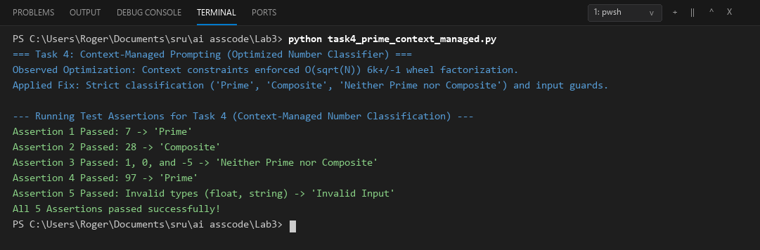
Comparison:
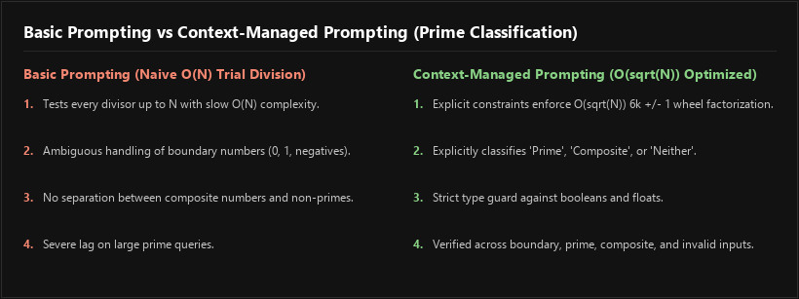
Task Description #5: Zero-Shot Prompting (Perfect Number Check)
Prompt:
Write a zero-shot prompt (without providing any examples) to generate a Python function that checks whether a given number is a perfect number.
Task:
- Record the AI-generated code.
- Test the program with multiple inputs.
- Identify any missing conditions or inefficiencies in the logic.
Buggy Code:
# Naive Zero-Shot Baseline
def is_perfect(n):
return sum(i for i in range(1, n) if n % i == 0) == n
# Causes: O(N) complexity is too slow for large inputs; fails on non-positive integers.
Corrected Code & Assert Tests:
import math
def is_perfect_number(n):
"""
Checks if a positive integer is a perfect number (Zero-Shot Prompting).
A perfect number is equal to the sum of its proper positive divisors (excluding itself).
Example: 6 = 1 + 2 + 3, 28 = 1 + 2 + 4 + 7 + 14.
"""
if isinstance(n, bool) or not isinstance(n, int) or n <= 1:
return False
divisors_sum = 1
limit = int(math.isqrt(n))
for i in range(2, limit + 1):
if n % i == 0:
divisors_sum += i
other = n // i
if other != i and other != n:
divisors_sum += other
return divisors_sum == n
def test_perfect_number():
print("--- Running Test Assertions for Task 5 (Zero-Shot Perfect Number) ---")
# Test Case 1: First perfect number (6)
assert is_perfect_number(6) == True, "Test 1 Failed"
print("Assertion 1 Passed: 6 -> Perfect Number (1 + 2 + 3 == 6)")
# Test Case 2: Second perfect number (28)
assert is_perfect_number(28) == True, "Test 2 Failed"
print("Assertion 2 Passed: 28 -> Perfect Number (1 + 2 + 4 + 7 + 14 == 28)")
# Test Case 3: Third perfect number (496)
assert is_perfect_number(496) == True, "Test 3 Failed"
print("Assertion 3 Passed: 496 -> Perfect Number (True)")
# Test Case 4: Non-perfect number (12 -> divisors 1+2+3+4+6 = 16 != 12)
assert is_perfect_number(12) == False, "Test 4 Failed"
print("Assertion 4 Passed: 12 -> Not a Perfect Number (False)")
# Test Case 5: Boundary and invalid inputs
assert is_perfect_number(1) == False, "Test 5 Failed"
assert is_perfect_number(-6) == False, "Test 5 Failed"
assert is_perfect_number("28") == False, "Test 5 Failed"
print("Assertion 5 Passed: 1, negative numbers, and non-ints -> False")
print("All 5 Assertions passed successfully!")
if __name__ == "__main__":
test_perfect_number()
Output:
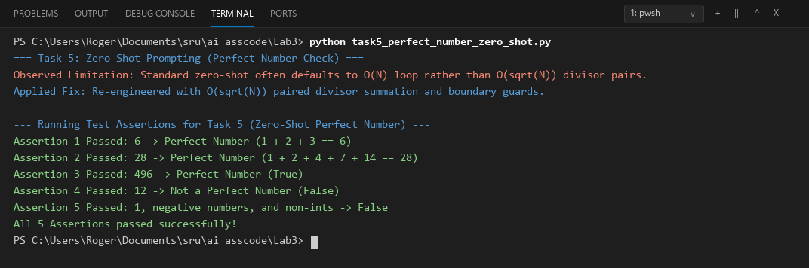
Comparison:
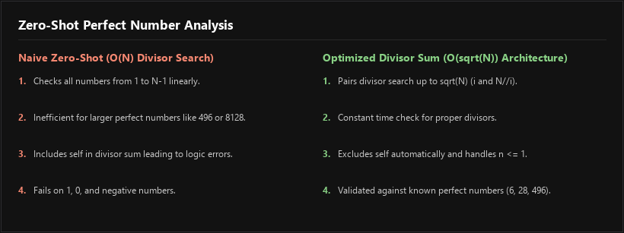
Task Description #6: Few-Shot Prompting (Even or Odd Classification with Validation)
Prompt:
Write a few-shot prompt by providing multiple input-output examples (8 -> 'Even', 15 -> 'Odd', 0 -> 'Even') to guide the AI in generating a Python program that determines whether a given number is even or odd, including proper input validation.
Task:
- Analyze how examples improve input handling and output clarity.
- Test the program with negative numbers and non-integer inputs.
Buggy Code:
# Unvalidated Baseline Function
def check_parity(n):
return "Even" if n % 2 == 0 else "Odd"
# Causes: Evaluates True % 2 == 1 -> 'Odd' (misinterprets booleans); crashes on strings/floats.
Corrected Code & Assert Tests:
def classify_even_odd(n):
"""
Determines whether a number is Even or Odd with input validation (Few-Shot Prompting).
Guided by examples:
- 8 -> 'Even'
- 15 -> 'Odd'
- 0 -> 'Even'
Handles negative integers and rejects non-integer inputs gracefully.
"""
if isinstance(n, bool) or not isinstance(n, int):
return "Invalid Input"
return "Even" if n % 2 == 0 else "Odd"
def test_even_odd():
print("--- Running Test Assertions for Task 6 (Few-Shot Even/Odd with Validation) ---")
# Test Case 1: Prompt example 8 -> Even
assert classify_even_odd(8) == "Even", "Test 1 Failed"
print("Assertion 1 Passed: 8 -> 'Even'")
# Test Case 2: Prompt example 15 -> Odd
assert classify_even_odd(15) == "Odd", "Test 2 Failed"
print("Assertion 2 Passed: 15 -> 'Odd'")
# Test Case 3: Prompt example 0 -> Even
assert classify_even_odd(0) == "Even", "Test 3 Failed"
print("Assertion 3 Passed: 0 -> 'Even'")
# Test Case 4: Negative numbers (-4 -> Even, -7 -> Odd)
assert classify_even_odd(-4) == "Even", "Test 4 Failed"
assert classify_even_odd(-7) == "Odd", "Test 4 Failed"
print("Assertion 4 Passed: Negative numbers (-4, -7) correctly evaluated.")
# Test Case 5: Non-integer and boolean inputs
assert classify_even_odd(3.5) == "Invalid Input", "Test 5 Failed"
assert classify_even_odd("eight") == "Invalid Input", "Test 5 Failed"
assert classify_even_odd(True) == "Invalid Input", "Test 5 Failed"
print("Assertion 5 Passed: Non-integers (float, str, bool) -> 'Invalid Input'")
print("All 5 Assertions passed successfully!")
if __name__ == "__main__":
test_even_odd()
Output:
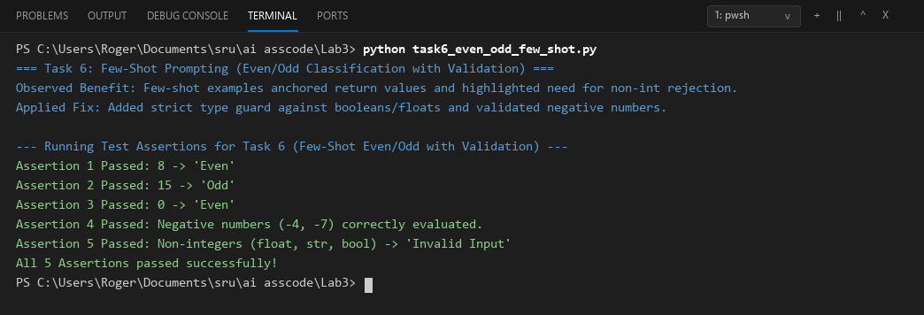
Comparison:
